**INDUSTRIAL TRAINING REPORT**

ON

***“RASPBERRY PI BOARD BASED ADVANCED EMBEDDED SYSTEM”***

Submitted in partial fulfillment of the requirements

for the award of the degree of

**BACHELOR OF TECHNOLOGY**

**IN**

**ELECTRONICS AND COMMUNICATION ENGINEERING**

Submitted By

**VAIBHAV GUPTA**

**Enrollment No: 36196202816**

**

**Department of Electronics & Communication Engineering**

**Dr. Akhilesh Das Gupta Institute of Technology & Management**

**Guru Gobind Singh Indraprastha University**

**Dwarka, New Delhi-110078**

**AUG-NOV - 2018**

**CERTIFICATE**

Certified that training work entitled “IOT USING ADVANCED EMBEDDED SYSTEMS AND RASPBERRY PI BOARD” is a bonafide work carried out in the seventh semester by “ VAIBHAV GUPTA” In partial fulfilment for the award of the degree of Bachelor of Technology in Electronics and Communication Engineering from Dr. Akhilesh Das Gupta Institute of Technology & Management during the academic year 2018-2019.

**Signature**

**Asstt. Prof. Kamal Malik**

**Signature**

**Prof.(Dr.) Rajiv Sharma**

**H.O.D, ECE Deptt.**

ii

**ACKNOWLEDGEMENT**

I would like to acknowledge the contributions of the following people, without whose help and guidance this report would not have been completed.

I acknowledge the counsel and support of our training coordinator, **Asstt. Prof. Kamal Malik, ECE Department,** with respect and gratitude, whose expertise, guidance, support, encouragement, and enthusiasm has made this report possible. Their feedback vastly improved the quality of this report and provided an enthralling experience. I am indeed proud and fortunate to be supported by him.

I am also thankful to **Prof.** (**Dr.) Rajiv Sharma**, **H.O.D of Electronics and Communication Engineering Department, Dr. Akhilesh Das Gupta Institute of Technology & Management, New Delhi** for his constant encouragement, valuable suggestions, moral support and blessings.

Although it is not possible to name individually, I shall ever remain indebted to the faculty members of **Dr. Akhilesh Das Gupta Institute of Technology & Management, New Delhi** for their persistent support and cooperation extended during this work.

My educators who motivated me to pursue this field of interest, this list would be incomplete if I didn’t mention the name of Mr. Shashank Singh,Sofcon India Pvt. Limited. He has been a constant source of nspiration and helped us understand a lot of concepts that were even beyond the scope of syllabi.

This acknowledgement will remain incomplete if I fail to express our deep sense of obligation to my parents and God for their consistent blessings and encouragement.

**VAIBHAV GUPTA**

**36196202816**

iii

**TABLE OF CONTENTS**

Page No:

Certificate i

Acknowledgement ii

Table of Contents iii

List of Figure iv

List of Tables v

**CHAPTER 1: INTRODUCTION AND LITERATURE SURVEY**

* 1. Introduction 1
  2. Literature Survey 2
  3. Motivation 4

**CHAPTER 2: TECHNOLOGY IMPLEMENTED**.

2.1 Raspberry Pi 5

2.2 Liquid Crystal Display 7

2.3 Relay Switch 8

2.4 Light Emitting Diode 9

2.5 Breadboard 10

2.6 Jump Wire 11

**CHAPTER 3: RESULT DISCUSSION**

3.1 The Training 13

3.2 The project 13

**CHAPTER 4: FUTURE SCOPE AND CONCLUSION**

4.1 Future scope 14

4.2 Conclusion 14

**CHAPTER 5: MERITS, DEMERITS AND APPLICATIONS**

5.1 Merits 15

5.2 Demerits 15

5.3 Applications 16

**APPENDIX** 18

iv

**LIST OF FIGURES**

|  |  |  |  |
| --- | --- | --- | --- |
| FIGURE NO. | FIGURE TITLE | SOURCE | PAGE NO. |
| 1.1 | Digital photo frame | https://bit.ly/2DpGuXc | 3 |
| 1.2 | Raspberry as a smart TV | https://bit.ly/2DpGuXc | 4 |
| 2.1 | Raspberry Pi | https://bit.ly/2DpGuXc | 5 |
| 2.2 | GPIO pin diagram | https://bit.ly/3SpBuWq | 6 |
| 2.3 | LCD Display | https://bit.ly/8SpBuWq | 7 |
| 2.4 | Relay Switch | https://bit.ly/9SqWeAs | 8 |
| 2.5 | LED | https://bit.ly/9SqWeAs | 9 |
| 2.6 | Breadboard | https://bit.ly/3SpBuWq | 10 |
| 2.7 | Jump wire | https://bit.ly/2DpGuXc | 11 |
| 2.8 | Microcontroller | https://bit.ly/8SpBuWq | 12 |

v

**LIST OF TABLES**

|  |  |  |
| --- | --- | --- |
| TABLE NO. | TITLE OF TABLE | PAGE NO. |
| 2.1 | Microprocessor Vs Microcontroller | 12 |
| 3.1 | Result discussion | 13 |

vi

**ABSTRACT**

Raspberry Pi is a credit-card sized computer manufactured and designed in the United Kingdom by the Raspberry Pi foundation with the intention of teaching basic computer science to school students and every other person interested in computer hardware, programming and DIY-Do-it yourself projects.

The Raspberry Pi is an affordable computer which has the maximum functionality and can be used as a fully-fledged computer which can be used for programming on various platforms and an added bonus for the microprocessor is the inclusion of GPIO pins and an inbuilt Wi-Fi-Bluetooth module which are beneficial for inter system communication purposes alongside various IOT protocols.

Its small size, ARM architecture, Linux based special OS are some of the key features that differentiate it from the various other computers available in the modern times.

Raspberry Pi’s are the best to introduce someone to the Linux Os builds and command line scripting.

My training with Raspberry Pi included a brief introduction to Linux commands, application of basic Electronics concepts, things to consider while buying electronic components , Arduino Interfacing ,Sensor integration using GPIO pins coded in the C language, all this was followed by a brief session on the Node MCU and AT language programming. The second half of my training was mainly project based where we were supposed to make practical solutions to the various day to day problems. My team worked on a home automation system that could be controlled via a Smartphone application.

vii

**CHAPTER 1**

**INTRODUCTION AND LITERATURE SURVEY**

**1.1 INTRODUCTION**

Raspberry Pi is a microprocessor which has a custom OS designed on the Linux build.

The Raspbian OS is a low Ram consuming operating system that can be boted on a Class 10 memory card of at least 8GB size and additional software’s can be installed using the command line interface.

The Raspberry Pi can be made to work for controlling purposes as well as processing purposes, but one should avoid using the Raspberry Pi for controlling purposes simply because it can be substituted by cheaper microcontrollers that can be as much as 5 times cheaper than Raspberry Pi itself.

Another point worth noting is that the Raspberry Pi can be coded using the i2c protocols,

It has 40 GPIO pins; however there are no analog pins this is one big disadvantages due to which one has to use an Analog to Digital Converter for controlling Analog sensors. The Raspberry Pi model 3B+ has an inbuilt WIFI and a Bluetooth module, HDMI cable connectivity for display output, it has a 3.5mm Jack for Audio output, besides that it has connection lines for connecting the TFT Pi Display and the PiCamera module.

The fundamental focus of my project was to make a complete project that serves up to ease life. Home Automation was the perfect field as it could make an efficient system for the users to control the various aspects of their household. We connected the system to Bluetooth so that one could execute the same using their Smartphone and with the press of a button, one could turn off the lights in a room. Relay switches were used as the intermediate layer to link up the DC logic and the AC power so that there is no compatibility issue within the two systems and they are both isolated from each other.

1

My training began with the basics of Linux, we studied about the various commands used in the terminal, we learnt about the different types of text editors used in the Raspberry Pi OS to edit and compile codes. Using the VIM text editor, we at first interfaced LEDs then moving onto pattern blinking of the LEDs and finally an LED chaser.

We began the next lot by studying the various sensors and most importantly interfacing the digitalRead functions by implementing a system that introduced us to the IR sensors. The IR sensors were then combined with LEDs to make a notification system of some sort and then we moved to pulse mode operation sensors such as the Ultrasonic sensor. Using the simple principle, we developed a few minor applications with the Ultrasonic Sensor where one could get the distance of an object ranging up to a few meters.

All this was followed by something that I have worked on with in my project. We began Relay interfacing, understanding the need of those sensors and also getting hands on experience with them. Right after this, we interfaced the HC05 Bluetooth module where we could actually connect our phone with the Raspberry Pi for various purposes.

Lastly, I learnt about the Arduino and motor interfacing with the same. This was thing which I felt would be really useful in making a concept robot which could be a mix of more than one technology.

**1.2 LITERATURE SURVEY**

Raspberry Pi has a lot of real life applications ranging from

1) WEB SERVER:- Fantastic use for a Raspberry Pi is to set it up as a web server. This basically means that it can be configured to host a website. It might host your blog, for example.

Several methods can be used. You’ll need to get started by installing the right software: Apache and its associated libraries. Or you might install a full LAMP stack, with PHP and MySQL alongside Apache. It’s useful if you also set up FTP.

Once these steps are completed, you can save HTML files into the /www/ directory, and your web server is ready. Or you might install some specific web software like Word Press, or its slim line competitor, Ghost.

2

**2) DIGITAL PHOTO FRAME :-** Off-the-shelf digital photo frames are attractive, if somewhat limited in space, storage, and purpose. What if they could do more than just display your favorite family photos?

Using this build, you can create a digital photo frame that delivers inspiring messages alongside photos of beautiful scenes from around the world. The result is something that dazzles your eyes while making you really think about the message. While we used a Raspberry Pi touch screen display for this project, any LCD display that can be connected to the Pi should be suitable.

You don’t have to use the project linked to above, either. There are many other great [**picture frame projects for the Raspberry Pi**](https://www.makeuseof.com/tag/7-fabulous-raspberry-pi-picture-frame-projects/)—you might use these as inspiration for your own project.

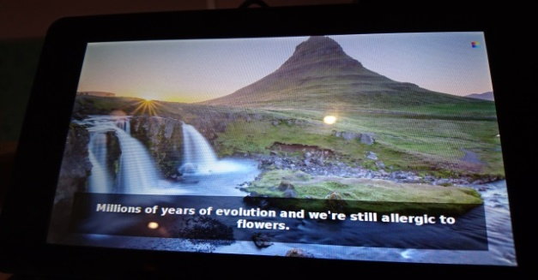

Fig:-1.1 Digital photo frame

3) **RASPBERRY PI AS A SMART TV:-** We’ve already looked at Kodi as a media center, but there are more TV-based entertainment projects you can do with a Raspberry Pi. In short, you can turn your standard, dumb TV into a smart TV. As if that wasn’t enough, you can even enhance the features of an existing smart TV!

For a TV to be “smart” it should be able to play media from a USB or flash storage device, stream video from Netflix, YouTube, and similar sites, and offer remote control. This is often from a mobile device when it comes to Raspberry Pi projects. Smart TVs should also offer news and weather, and PVR support, which a Raspberry Pi can manage thanks to a USB TV card.

Beyond Kodi (or in conjunction with it) a Raspberry Pi can be used as a Plex client. This means that you have a PC or server running Plex, and have the RasPlex software installed on your Pi. Browsing the server’s media should be straightforward, enabling you to enjoy all movies, TV shows and music stored upon it.

3

Meanwhile, the Raspberry Pi 3 can mimic the Google Chrome cast thanks to Miracle Cast. This means you can “cast” video from your mobile device to your Pi. Pretty handy! Other smart TV projects are available, as you’ll discover.

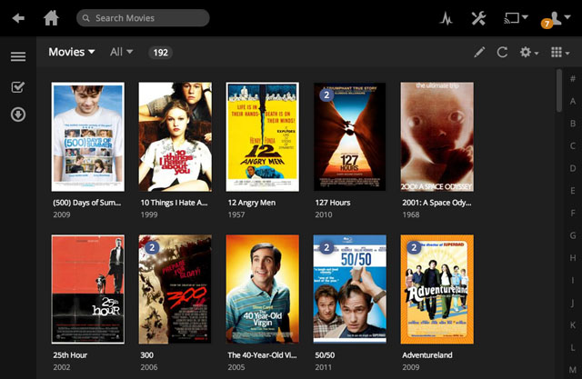

Fig:-1.2 RASPBERRY PI AS A SMART TV

**1.3 MOTIVATION:-**

Ever since I began with my B.Tech, I had interest in the core principles of micro processing and micro controlling. As a kid, I was always fascinated by making stuff that works. My first school level project in the fourth grade was making a solar water heater and by my ninth grade the most fascinated project I worked on was making a mechanically working non electrical washing machine. My fundamental aim thereafter was field engineering.

4

**CHAPTER 2**

**TECHNOLOGY IMPLEMENTED**

**2.1 RASPBERRY PI:-** Raspberry Pi is a credit-card-sized computer that plugs into your TV and a keyboard. It is a capable little computer which can be used in electronics projects, and for many of the things that your desktop PC does, like spreadsheets, word processing, browsing the internet, and playing games. It also plays high-definition video. We want to see it being used by adults and children all over the world to learn programming and digital making.

**FEATURES:-**

* Broadcom BCM2837B0, Cortex-A53 (ARMv8) 64-bit SoC @ 1.4GHz
* 1GB LPDDR2 SDRAM
* 2.4GHz and 5GHz IEEE 802.11.b/g/n/ac wireless LAN, Bluetooth 4.2, BLE
* Gigabit Ethernet over USB 2.0 (maximum throughput 300 Mbps)
* Extended 40-pin GPIO header
* Full-size HDMI
* 4 USB 2.0 ports
* CSI camera port for connecting a Raspberry Pi camera
* DSI display port for connecting a Raspberry Pi touch screen display
* 4-pole stereo output and composite video port
* Micro SD port for loading your operating system and storing data
* 5V/2.5A DC power input
* Power-over-Ethernet (PoE) support (requires separate PoE HAT)

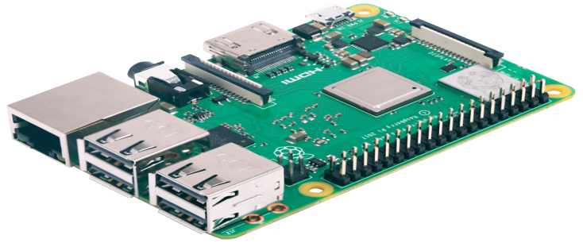

Fig:-2.1 RASPBERRY PI

5

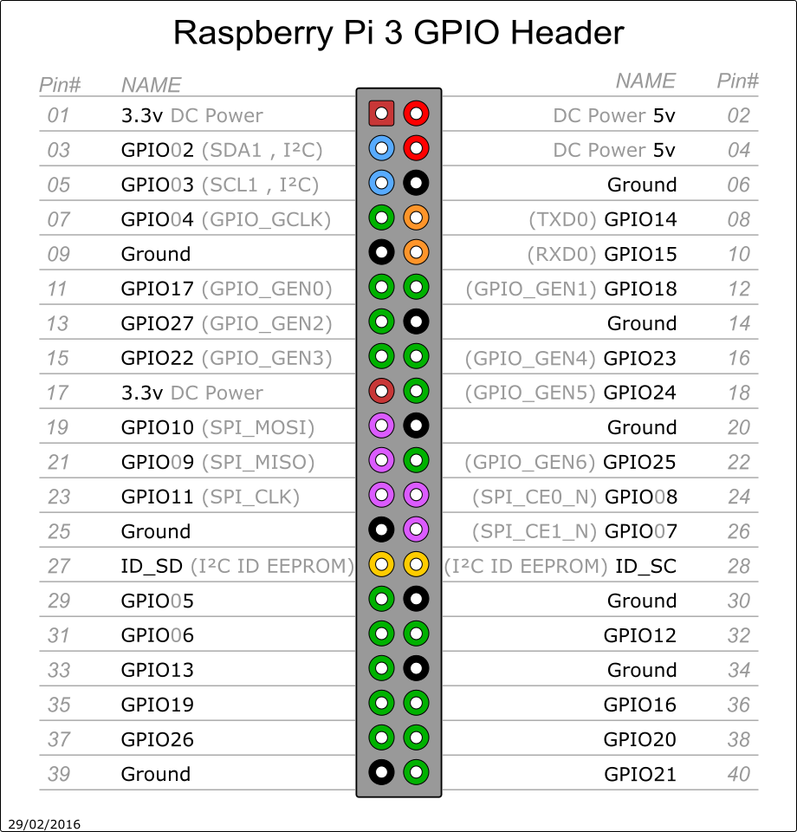

Fig:-2.2 GPIO PIN DIAGRAM

6

**2.2 LIQUID CRYSTAL DISPLAY:-**

A liquid-crystal display (LCD) is a flat-panel display or other electronically modulated optical device that uses the light-modulating properties of liquid crystals. Liquid crystals do not emit light directly, instead using a backlight or reflector to produce images in color or monochrome. LCDs are available to display arbitrary images (as in a general-purpose computer display) or fixed images with low information content, which can be displayed or hidden, such as preset words, digits, and seven-segment displays, as in a digital clock. They use the same basic technology, except that arbitrary images are made up of a large number of small pixels, while other displays have larger elements.

There are some advantages of liquid crystal display (LCD) which are given below,

* The LCD can be made in large sizes of over 60 inch or 150 cm diagonal.
* It has no geometric distortion.
* It is very compact, thin, and light CRT displays.
* It does not affect by the magnetic fields.
* Due to low power consumption, small heat emitted during operation.
* It is much thinner than a CRT (cathode ray tube) monitor.

There are some disadvantages of liquid crystal display (LCD) which are given below,

* In high temperature environments there is loss of contrast.
* It is relatively bright but not suitable for very brightly environments.
* It consumed a lot of electricity which produce a lot of heat.
* It has individual liquid crystals which cannot complete all block of the backlight.
* From the viewing angle, the color and contrast not consistent.

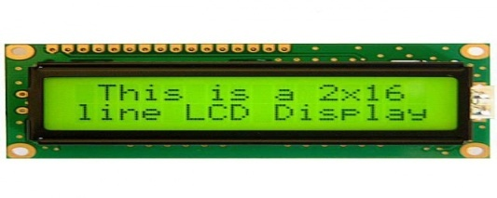

Fig:-2.3 LCD Display

7

**2.3 RELAY SWITCH:-**

A relay is an electrically operated switch of mains voltage. It means that it can be turned on or off, letting the current go through or not.

* **GND**: goes to ground
* **IN1**: controls the first relay.
* **IN2**: controls the second relay.
* **VCC**: goes to 5V

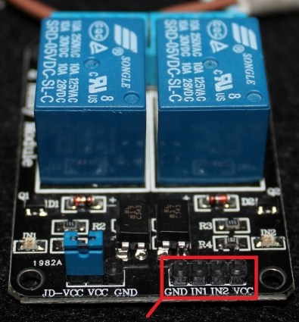Relays are switches that open and close circuits electromechanically or electronically. Relays control one electrical circuit by opening and closing contacts in another circuit. As relay diagrams show, when a relay contact is normally open (NO), there is an open contact when the relay is not energized. When a relay contact is Normally Closed (NC), there is a closed contact when the relay is not energized. In either case, applying electrical current to the contacts will change their state.

Fig 2.4:- Relay Switch

Advantages of Relays

* The complete electrical isolation improves safety by ensuring that high voltages and currents cannot appear where they should not be.
* Relays come in all shapes and sizes for different applications and they have various switch contact configurations.  Double Pole Double Throw (DPDT) relays are common and even 4-pole types are available.  You can therefore control several circuits with one relay or use one relay to control the direction of a motor.
* It is easy to tell when a relay is operating - you can hear a click as the relay switches on and off and you can sometimes see the contacts moving.

##### Disadvantages of Relays

* Their parts can wear out as the switch contacts become dirty - high voltages and currents cause sparks between the contacts.
* They cannot be switched on and off at high speeds because they have a slow response and the switch contacts will rapidly wear out due to the sparking.
* Their coils need a fairly high current to energize, which means some micro-electronic circuits can't drive them directly without additional circuitry.
* The back-emf created when the relay coil switches off can damage the components that are driving the coil.  To avoid this, a diode can be placed across the relay coil, as will be seen in any *Electronics in Mecca no* circuits that use relays with sensitive components.

8

**2.4 LIGHT EMITTING DIODE:-**

A light-emitting diode (LED) is a two-lead semiconductor light source. It is a p–n junction diode that emits light when activated. When a suitable current is applied to the leads, electrons are able to recombine with electron holes within the device, releasing energy in the form of photons. This effect is called electroluminescence, and the colour of the light (corresponding to the energy of the photon) is determined by the energy band gap of the semiconductor. LEDs are typically small (less than 1 mm2) and integrated optical components may be used to shape the radiation pattern.

A P-N junction can convert absorbed light energy into a proportional electric current. The same process is reversed here (i.e. the P-N junction emits light when electrical energy is applied to it). This phenomenon is generally called electroluminescence, which can be defined as the emission of light from a semiconductor under the influence of an electric field. The charge carriers recombine in a forward-biased P-N junction as the electrons cross from the N-region and recombine with the holes existing in the P-region. Free electrons are in the conduction band of energy levels, while holes are in the valence energy band. Thus the energy level of the holes is less than the energy levels of the electrons. Some portion of the energy must be dissipated to recombine the electrons and the holes. This energy is emitted in the form of heat and light.

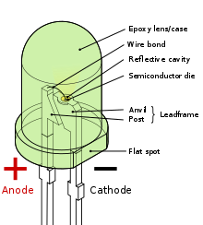

Fig 2.5:-LED

9

**2.5 BREADBOARD:-**

A breadboard is a construction base for prototyping of electronics.

Because the solder less breadboard does not require soldering, it is reusable. This makes it easy to use for creating temporary prototypes and experimenting with circuit design. For this reason, solder less breadboards are also popular with students and in technological education. Older breadboard types did not have this property. A strip board (Vero board) and similar prototyping printed circuit boards, which are used to build semi-permanent soldered prototypes or one-offs, cannot easily be reused. A variety of electronic systems may be prototyped by using breadboards, from small analog and digital circuits to complete central processing units (CPUs).

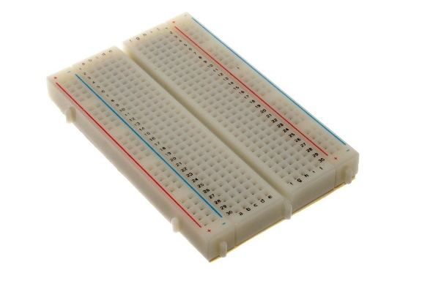

Fig 2.6:-Breadboard

10

**2.6 JUMP WIRE:-**

Stranded 22AWG jump wires with solid tips.

A jump wire (also known as jumper, jumper wire, jumper cable, DuPont wire, or DuPont cable – named for one manufacturer of them) is an electrical wire, or group of them in a cable, with a connector or pin at each end (or sometimes without them – simply "tinned"), which is normally used to interconnect the components of a breadboard or other prototype or test circuit, internally or with other equipment or components, without soldering.

Individual jump wires are fitted by inserting their "end connectors" into the slots provided in a breadboard, the header connector of a circuit board, or a piece of test equipment.

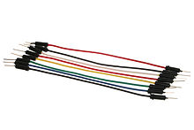

Fig2.7 Jump Wire

**MICROPROCESSOR VS MICROCONTROLLERS**

11

|  |  |
| --- | --- |
| **MICROPROCESSOR** | **MICROCONTROLLER** |
| **Used for processing.** | **Used for controlling or a dedicated function.** |
| **It has higher RAM varying in GBs.** | **It has very low RAM varying up to a few KBs.** |
| **It has a working OS.** | **It has a firmware.** |
| **Operating frequency is in GHz.** | **Operating frequency is a few MHz.** |

Table 2.1:- Microcontroller Vs Microprocessor

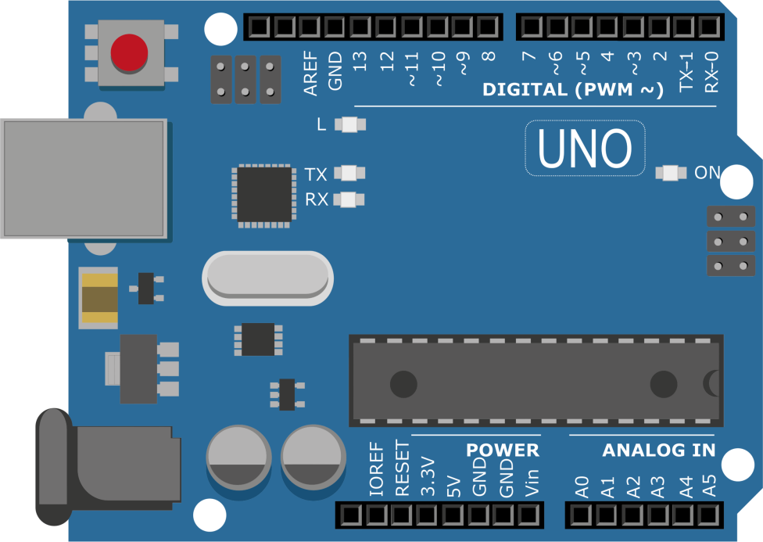

2.8:-Microcontroller

12

**CHAPTER 3**

**RESULT DISCUSSION**

**3.1 The Training:-**

By the completion of the training, I had gained knowledge that is somewhat not found in any book, any manuscript but can only be attained by practically implementing ideas. I would exemplify the same by mentioning that until the time I fused a few components, I had no understanding of how those things worked. The hands on experience added a great amount of knowledge, enabled me to broaden my horizon, helped me work on things I only imagined are possible, but most importantly, it made me an independent individual who delivers a quality product with major success.

**3.2 The Project:-**

The mini projects I worked upon helped me understand the concepts taught in class and taught me to build a complete system that is void of failures and has the perfect balance of user comfort alongside being feature rich. One of the concepts I specifically learnt to deal with by working on projects was the cost effectively of the projects and building something at the minimum pricing possible in an efficient manner. Each project I did introduced me to concepts not limited to the syllabi I am prescribed with, this activity helped me get into a habit of wide reading which I believe serves as a boon for me.

|  |  |
| --- | --- |
| **Before training and projects** | **After training and projects** |
| Void of knowledge | Clear with basic concepts |
| No habit of wide reading | Turning stones left unturned |
| Zero practical experience related to processing and controlling | Did more than one projects based on different applications within a span of three months |
| Nervous socially due to incompetence  Fig 3.1:- Result discussion | Brightly confident and engaging in discussions |

13

**CHAPTER 4**

**FUTURE SCOPE AND CONCLUSION**

**4.1 FUTURE SCOPE**

We convert house into a smart house by giving control on your Smartphone/tablet and touch panels. You can control lighting, curtains, home cinema, media server, surveillance, climate control, background music, we customize just as per your taste and design. To empower customers with affordable and innovative technology solutions for happy and safe living.

**Conceptual testaments’:-**

* Intuitive Mobile

App for IOS/Android on play store.

* Simple and quick configuration.

* Seamlessly Integrated with following platforms

IFTTT/Amazon Alexa/Google Assistant/Crotona

The Raspberry Pi a small sized compact processor which is having computing power for its size. Nowadays there is an increase in technologies and in various portable devices in those device may be one day the Raspberry might also be used as it has multiple GPIO pins which can be built by or programmed and use to interface various device3s in the real world and controlled by the python programming language.

**4.2 CONCLUSION**

In this project report Raspberry provides security and various ways to control the devices in the house. Because of mobile phones the living is comfortable and at the same time it can be easily accessible through portable devices. It gives users all the rights to decide which makes it reliable as it always ask before taking any decision, it helps when there are any necessary decision ,it helps when there are any necessary decisions to be taken and they can be taken fast in case of an emergency.

14

**CHAPTER5**

**MERITS, DEMERITS AND APPLICATIONS**

**5.1 MERITS:-**

* **Adding Convenience to your Daily Life –**When you convert your home into a smart home, you’ll have all of your products programmed to your specific needs. Additionally being able to control your home, no matter where you are, can be extremely beneficial.
* **Customization –**There are many smart products on the market right now and you certainly don’t need to buy all of them at once. As the consumer it’s up to you to decide which product you want most, determine if you like it, and then add on to your collection of smart home products as you go.

A good product to start with would be a thermostat or home security system if you’re in the market for either of those.

* **Security –**Smart home security systems allow you to view your home no matter where you are. You can have cameras installed, motion detectors, locks, etc, and you will be notified immediately if something is out of the ordinary. Many of these systems will even let you know of any unexpected temperature changes so that you’re alerted if there is a possible fire.
* **Ease of Use –**Almost all smart home products can be installed without much hassle; many of them don’t even require you to bring someone into your home. Additionally if you’re already someone who’s tech savvy, learning how to use most of these products is a breeze.
* **Save Money and the Environment –**Smart homes feature products like thermostats, air conditioners, and lighting. Having the ability to put these things on a timer, or turn them on and off when you’re away from home will likely help you save money on your electricity bills. Many of these products allow you to track your energy usage and expenditures.

**5.2 DEMERITS:-**

* **Cost –**Most families are able to purchase smart home products, but that doesn’t mean it won’t leave a dent in your wallet. You can purchase the products one at a time and it won’t seem like too much, $50 here, $300 there, but by the time you

15

Have the smart home system you want, you will likely have spent a larger sum than you would have if you had purchased non-smart products.

* **Slight Learning Curve –**I know I stated in the advantages that most smart home systems are actually very easy to use, but at the same time there is still somewhat of a learning curve for most people. For anyone already immersed in technology, converting your smart home will be a breeze, but for anyone not so tech savvy, it may make for a lot of time spent reading manuals.

If you think you might have trouble learning how to use a smart home device, the answer may be simple. Ask for help! Asking someone to show you how to run your smart home can far less confusing than trying to make heads or tails of an instruction manual.

* **Reliability –**A smart home will be extremely reliant on your internet connection. If your connection drops you’ll be left with a lot of smart products that won’t work. Additionally, wireless signals can possibly be interrupted by other electronics in your home and cause some of your smart products to function slowly or not at all.

There are plenty of pros and cons to consider when deciding whether you’d like to convert your home into a smart home. Smart homes aren’t for everyone. They can help bring down your electricity bills, simplify your daily tasks, and help to give you a feeling of security. But for some people smart home product will simply turn into an economic burden. It’s ultimately up to you to decide which category you fall into.

**5.3 APPLICATIONS:-**

Iot based home automation can revive the way people use technology. There is a considerable range of possibilities when we speak about applications of home automation.

* Controlled electrical fixtures such as lights and air conditioners.
* Simplified garden or lawn management.
* HVAC
* Controlled smart Home appliances.

16

* Enhanced safety and security at home.
* Water and air quality control and monitoring.
* Voice based home assistant Language.
* Smart locks and switches.

These are a few, but not all the possible applications of home automation using Iot.As technology advances, there will be more added to the list.

17

**APPENDIX**

#include<stdio.h>

#include<string.h>

#include<errno.h>

#include<wiringPi.h>

#include<wiringSerial.h>

void main()

{int serial_port,x=0;

WiringPiSetup ();

pinMode (0,OUTPUT);

pinMode(1,OUTPUT);

pinMode(2,OUTPUT);

pinMode(3,OUTPUT);

digitalWrite(0,HIGH);

digitalWrite(1,HIGH);

digitalWrite(2,HIGH);

digitalWrite(3,HIGH);

char dat;

if((serial_port=serialOpen("/dev/ttySO",9600))<0)

18

{ fprintf(stderr,"Unable to open serial device : %s \n",strerror(errno));

}

if(wiringPiSetup()==-1)

{ fprintf(stdout,"unable to start wiringPi : %s \n",strerror(errno));

}

while(1)

{ if(serialDataAvail(serial_port))

{ dat=serialGetchar(serial_port);

printf("%c \n",dat);

fflush(stdout);

}

if(dat=='a')

{ digitalWrite(0,HIGH);

printf("Relay A On");

}

if(dat=='b')

{ digitalWrite(1,HIGH);

printf("Relay B ON");

}

if(dat=='c')

{ digitalWrite(2,HIGH);

printf("Relay C ON");

}

if(dat=='d')

{ digitalWrite(3,HIGH);

printf("Realy D ON");

}

}

}

18

18